

UCLA Family Medicine Research Unit Meeting
UCLA Family Medicine 10880 Wilshire Blvd., Suite 1800, 18th floor Conference Room

AGENDA

Thursday, March 3, 2022 from 11:00am – 12:00pm
Zoom: https://uclahs.zoom.us/j/319497060; Password: Research
Dial-In Number: (669) 900-6833 Access Code: 319 497 060 #

- Recently Processed Research Funding (since last meeting)
PI | Award Title | Sponsor | Prime Sponsor | Award Type | Action Type
Tarn, Derjung Mimi | Development & Implementation of the Technology-Enabled Alliance for Medication Therapy Management (TEAM) | Northwestern University | Gordon and Betty Moore Foundation | Subgrant | Continuation
We also received notice that Dr. Shoptaw’s 5-yr CHIPTS center grant has been renewed, but it’s still being processed by OCGA.

- Outgoing Proposals (since last meeting)
PI | Title | Sponsor | Prime Sponsor | Anticipated Award Type | Overall Proposal Type | Project Begin Date
Gelberg, Lillian | Individual and Place Effects Influencing the Experience of Homelessness and Exiting Homelessness | University of North Carolina | NIH | Subgrant | New | 12/1/2022
In progress: Kalmin R01, Castellon VaxUp, Li R21 resubmission.
Submitted outside of Fam Med: Tarn 3 Wishes submitted via DOM, and Moreno HRSA submitted via Dean’s office
- Human Resources/Personnel
  - New Employees
    - Christine Park joined our department as of March 1. She has over 11 years of experience at UCLA, including experience as a fund manager with the School of Education of Information Studies. She will be the fund manager for all PI’s except Drs. Bholat, Dowling, Moreno, and Sur. Please take a moment to introduce yourself over the next few days and if you are a PI, please reach out to her to schedule both an initial meeting and a recurring monthly meeting, if you have not already done so.
  - Campus closed on Monday, Mar 25 for Chesar Chavez Day
  - W2s available on UCPath. Click on Employee Actions > Income and Taxes > View Online W-2
  - 2021-2022 Performance Evaluations are now open for career staff in non-represented, non-academic positions. Employees should have received notification via Cornerstone that self-evaluations are open and due by March 13. Supervisor evaluations will be open March 14-April 10.
  - New UCLA Health Sciences Volunteer Clearance process

- COVID/Hybrid Updates
  - Don’t forget to complete the UCLA COVID-19 Symptom Monitoring System for each day you plan to be in person.
  - Weekly testing required for hybrid employees at Oppenheimer; must utilize UCLA testing kits/system
- Other
  - The DOFM Culture Survey was sent to all employees and we are asking for 100% participation. Responses will remain anonymous and will help us identify our department’s strengths and weaknesses. Please take the 7-minute survey ASAP if you have not already done so.
  - Please RSVP for the Department Retreat, which will be held via Zoom on March 30, 2022. There are two sessions (8:30a-11:30a, and 12:30p-3:30p) and you should only choose 1. Email Denise Acelar to RSVP with which session you will attend. The department is hoping for 100% participation, even if you are new to our team.
  - Meet and Greet with the Residents: Wednesday, June 22. Mandatory for all faculty. Please let Laura know what time slot you prefer.
  - Research Day 2022: Abstracts are due April 1. Submission Guidelines. The website has been updated with guidelines, and the Online Submission Form is active. Research Day itself will be held on May 11.
- Financial
  - Updated Mileage Reimbursement Form is available on our website.
  - Valencia now has account to pay for medical license renewals, so doctors should submit PO Request Forms and coordinate with Valencia to pay for this, instead of paying out of pocket and seeking reimbursement.
  - Travel reimbursements, PTAs, Entertainment expenses, etc.
- Proposals and Contracts/Grants
- New CBR Rates
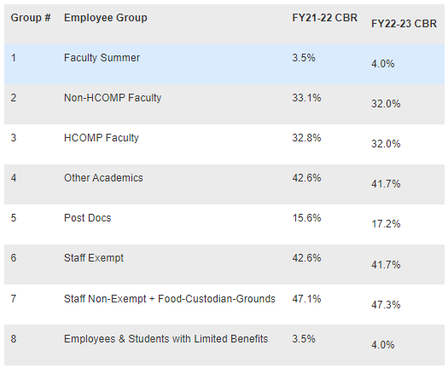
- New Salary Cap : $203,700
- New NIH Other Support Page now in effect. In addition to the new format, it MUST be signed via DocuSign*
- *DocuSign
  - Required for a variety of research forms, including the new Other Support pages.
  - You must take the required DocuSign Sender Training in order to create new DocuSign documents. Log into Cornerstone and search for course “ELRSH902.” The course is online, free, and takes approximately 45 minutes.
  - Once you have completed training, you will be able to access the UCLA DocuSign website and upload documents for signature.
  - If you want to sign a document yourself, click on the “Start” button and select “Sign a Document.”
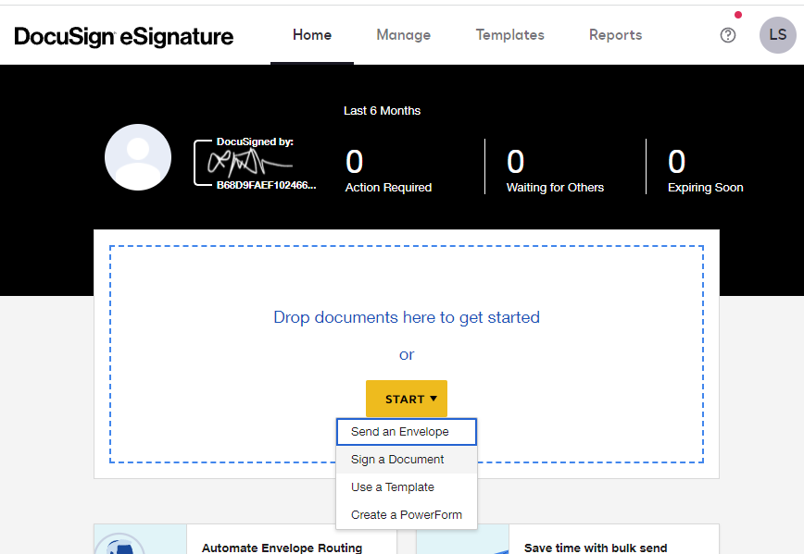
Then click on “Upload” and upload the document you want to sign (e.g. the Other Support page).
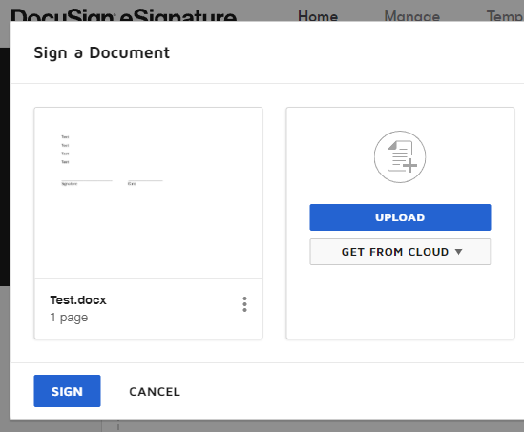
Once the document has uploaded, click “Sign.”
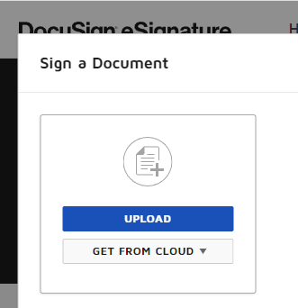

The document will open and the system will ask you to review the document. Click “Continue.” You can then drag and drop your signature, date, initials, etc. where needed on the form.
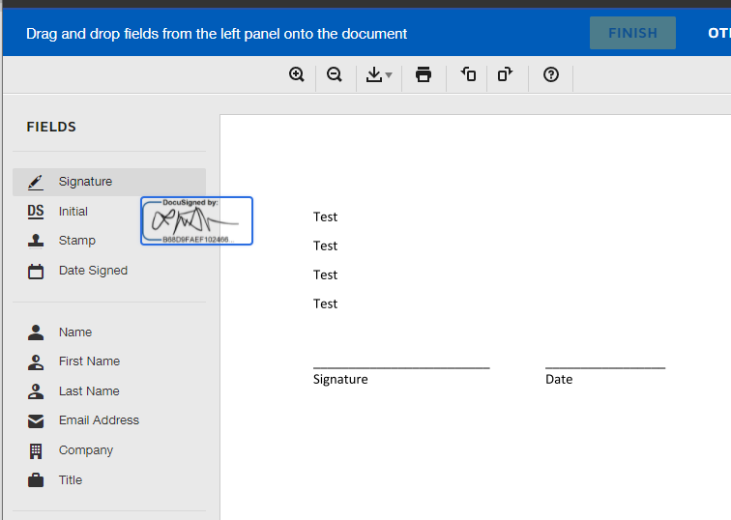

When you have finished adding your signature(s), click “Finish.”

The system will then send you an email with a link to your completed/signed document. A window will also pop up, giving you the opportunity to directly send the signed document to anyone else you’d like.
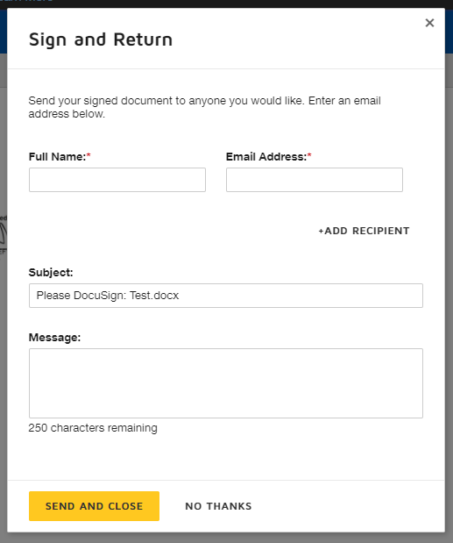

  - If you want to send a document to someone else to have them sign it, you can drag and drop the document into the box, or click on “Start” and select “Send an Envelope.” From there, you will type in the recipient name(s) and email(s), and any message you’d like to include.
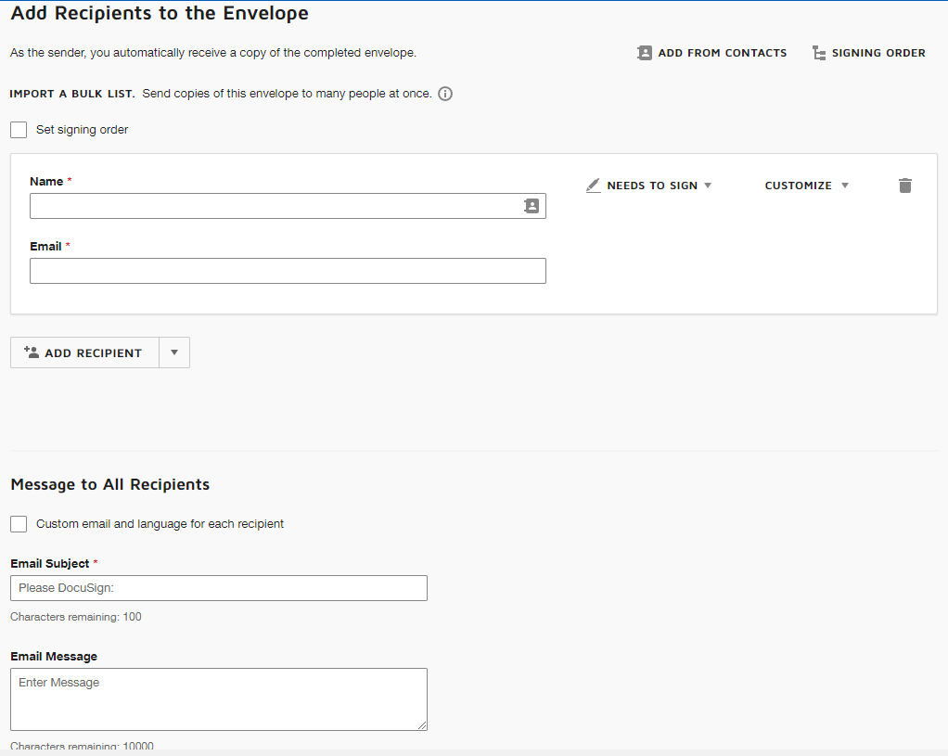
From there, the process is similar to that described above. You can drag and drop whatever fields you need the recipient to complete (e.g. singature, date, initials, check box, etc.). Then you can send it to the recipients and they will receive an email with instructions and link to the document. Once the pary(ies) have signed, DocuSign will send you and the signees an email with a link to the completed document.
- New Proposal Intake Form, restructured due to new Online EPASS
- Required Documents for Subawards is now available on our website
- Effective with the FY 2022 May/June Council round, Advisory Council members will continue to provide additional consideration of new and renewal applications from well-supported investigators who currently receive $2 million or more in total costs, per year of active NIH funding (e.g. grants and cooperative agreements)
- Training: My next training topic will be Preparing Research Proposal Budgets.
  - The department will send out a Doodle link to everyone later this month; if you are interested in joining the session please respond to that poll.
  - If you work with residents, fellows, or junior researchers who may be interested in this topic, please ask them to respond to the poll or have them reach out to me directly.
  - If you missed one of our previous trainings, feel free to check out the slides on our website.
- IRB will no longer collect PI Exception Letters, but they are still required
- COVID-19 Research Funding Opportunities
- Funding Opportunity Resources

- IT/Computer/Phone
  - Website updates are in progress, please email Laura your updated information if you haven’t done so already
  - Mandatory Windows Update this weekend. Please log off but leave your computers on when you leave on Friday.
- Office Safety/Emergency Preparedness
  - Time to renew/complete your Oppenheimer building training: Link for returning users. Link for new users. If you are a new hire/user, please use this dept. specific registration code: 765229D
  - Please give Laura your emergency contact information if you haven’t already done so, and update as needed. Personal cell phone, home phone, personal email, name/contact info for emergency contact person.

- Wellbeing Resources
  - Available Mental Health Resources
  - UCLA Recreation Virtual Fitness & Wellness Classes and Events
  - DGSOM Reporting and Support Resources
  - UCLA Counseling and Psychological Services
- University Initiatives
  - Think Outside the Landfill Challenge
  - Equity, Diversity, and Inclusion toolkits, including “Dismantling Racism: Resources and Best Practices”
- Upcoming Meeting
- Next Research Unit Meeting: April 7
- PI’s: please reach out to Laura to reserve a month for you to present during one of our upcoming meetings. All PI’s are welcome (and expected to) present.
- Please send any agenda items to Laura 3 days before the next month’s meeting.

